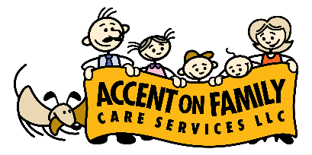
Coronavirus Pandemic Plan
The following are procedures that ACCENT on Family Care Services has in place in case of illnesses such as the Coronavirus.
The Coronavirus symptoms can include fever, coughing and difficulty breathing. Some people may get a very mild case but can still spread it to others. It is a highly contagious and potentially dangerous and is spreading rapidly.
The following are health and safety procedures that can help to avoid catching the virus or spreading the virus to others.
- Wash hands with soap at the beginning of your shift and at the end of your shift before you leave.
  - When washing hands, make sure it is for a minimum of 20 seconds, wash between all fingers and thumb, the tips of fingers and up to the wrists. Rinse thoroughly.
- Wash hands every time the you change locations.
- Wash hands before and after doing toileting or diapering for a member.
- Always avoid touching your face and avoid touching the member’s face if it is not necessary for their care.
- Refrain from handshakes and hugs.
- Cover your cough or sneeze with a tissue, then throw the tissue in the trash and wash hands afterwards.
- Do not work with a family if you have any cold symptoms, especially if you have a fever.
- If you notice anyone in the home you work at has a cough, fever, flu, or other virus or active infection, call ACCENT on Family Care Services.
- Employees must report to ACCENT on Family if they cancel a scheduled visit due to illness or for any other reason.
- Face masks and gloves are highly recommended. Contact ACCENT if you need these supplies for work.
***If an ACCENT employee has been EXPOSED to someone who had TESTED POSITIVE for the Coronavirus, they must contact Debbie Belnap with ACCENT on Family Care Services right away. Employees exposed to the virus must stay away from the families and individuals they work with for 14 days to be sure they did not contract the disease. It is of the utmost importance to visit your physician if you experience symptoms associated with the Coronavirus as stated above.
***Employees who test positive for the Coronavirus must report it to Debbie Belnap with ACCENT immediately and refrain from working until their doctor has cleared them to work again. If an employee does get the virus, they must provide a written statement from the doctor that they are free from the virus and allowed to work.
***All we have is each other. Your safety is my safety. Protecting yourself means protecting those around you, too.
***For more information on the Coronavirus with steps to prevent illness, go to the Centers for Disease Control and Prevention website: https://www.cdc.gov/coronavirus/2019-ncov/index.html
I understand and agree to follow the above pandemic plan and the stated health and safety procedures:
(Employee Signature)____________________________________________________Date:___________

